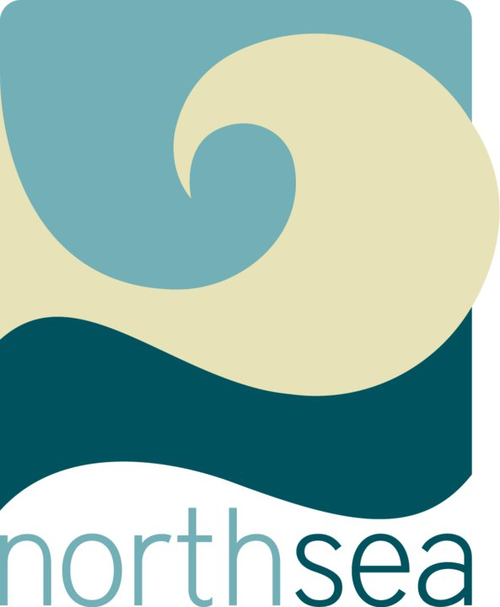
The North Sea continues its Free Acupuncture Days in 2011.

Happy New Year from North Seattle Community Acupuncture! In 2011, we are continuing our once-a-month Free for Me and My Friend days. Bring someone new to the clinic on one of these days and you both receive a free treatment. Bringing only yourself? That works too! Our next free day is Saturday, January 8th, 9am to 1pm.
We are located at 11329 Pinehurst Way NE, just two blocks north of Roosevelt and Northgate Way. Our usual fee is $15-$40, pay what's comfortable. It's all about getting healthy without making your wallet sick. You can make your own appointment on our website at www.northseaforme.com or call us at 206-524-6428. See you soon!

