pinehurstfest
Saturday, July 16, 2-5 pm
Pinehurst Playfield: 12029 14th Ave NE
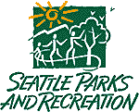

Celebrate our neighborhood at Pinehurstfest –
the Pinehurst neighborhood summer social!
- Meet your neighbors
- Live music
- Children’s activities & bouncy castle
- Refreshments
- Local community organizations
- Donation barrels will collect food for North Helpline
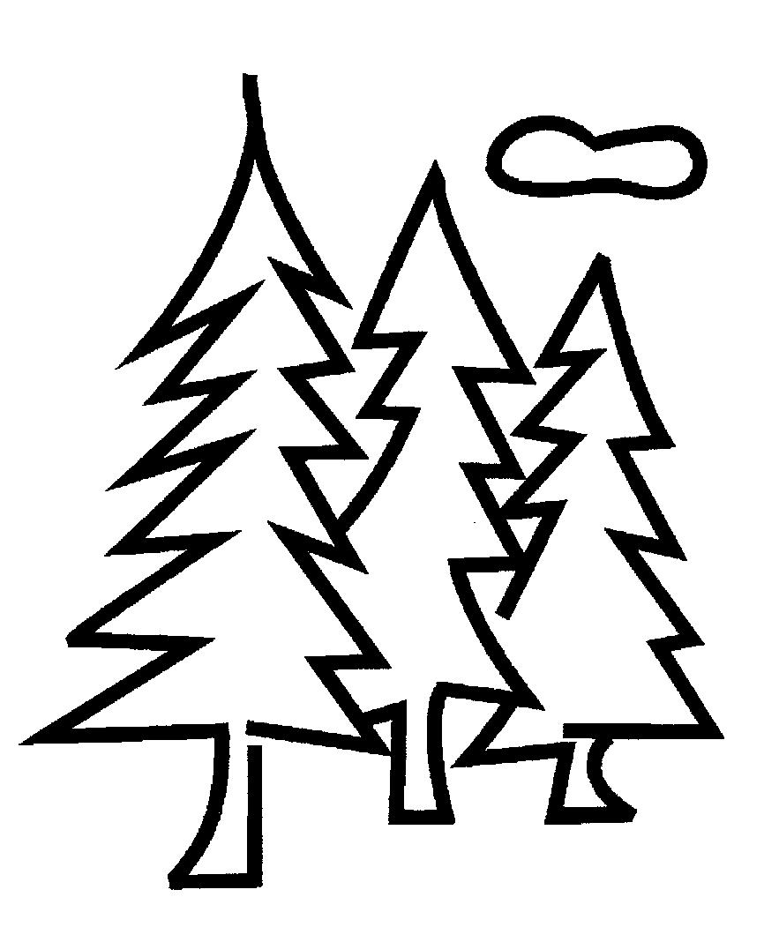
A group of your neighbors, the Pinehurst Community Council, organized Pinehurstfest in partnership with the Meadowbrook Community Center. This project is sponsored in part by Seattle Parks and Recreation.
Pinehurstfest is a FREE festive family outdoor celebration for everyone in our neighborhood.
Please join us!

Learn more and get involved:
www.pinehurstseattle.org

